# [**'SVU,' 'Blue Bloods' & More Shows Making Changes Amid Police Brutality Protests**](https://www.tvinsider.com/gallery/tv-shows-changes-2020-police-brutality-protests/)

[***Meredith Jacobs***](https://www.tvinsider.com/author/meredith-jacobs/)AUGUST 17, 4:30 PM

* F,{e3b0e020-50eb-43a6-b034-4d07d5b4e73d}{86},0.6666667,0.6666667
* F,{e3b0e020-50eb-43a6-b034-4d07d5b4e73d}{102},0.6666667,0.6666667
* F,{e3b0e020-50eb-43a6-b034-4d07d5b4e73d}{118},0.6666667,0.6666667

[2 COMMENTS](https://www.tvinsider.com/gallery/tv-shows-changes-2020-police-brutality-protests/#spotim)

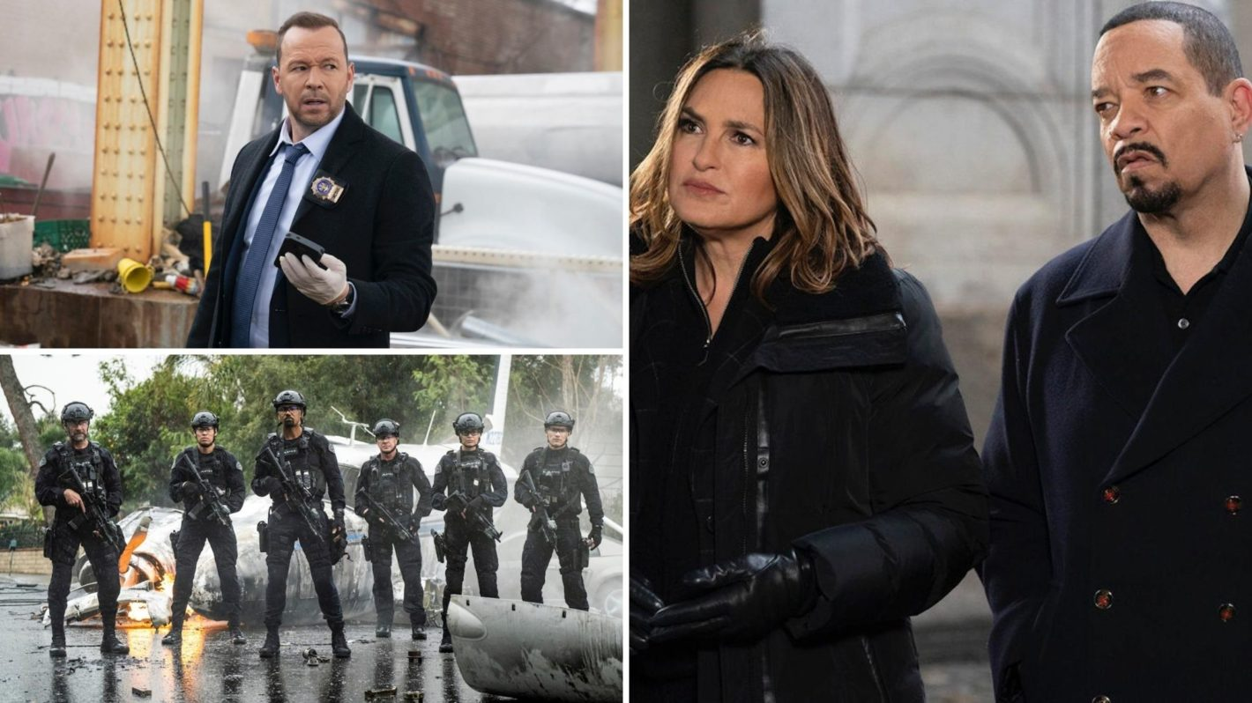

Patrick Harbron/CBS; Jordin Althaus/CBS; Virginia Sherwood/NBC

While the question for medical dramas heading into the 2020-2021 season is focused on the incorporation of the coronavirus pandemic, people are wondering whether shows about law enforcement will make any changes due to the protests against racism and police brutality following George Floyd's death.

Several have already announced that they will be adjusting their approach to depicting cops in the new seasons, whether it's addressing it head-on or being "more mindful," as [***Blue Bloods***](https://www.tvinsider.com/show/blue-bloods/) star [**Donnie Wahlberg**](https://www.tvinsider.com/people/donnie-wahlberg/) (who plays Detective Danny Reagan) told [**TV Insider**](https://www.tvinsider.com/942119/donnie-wahlberg-blue-bloods-season-11-changes-police-brutality/).

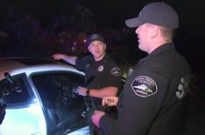[SEE ALSO](https://www.tvinsider.com/938277/cop-reality-shows-backlash-cops-live-pd/)

### [**Inside the TV Industry's Crackdown on Cop Reality Shows**](https://www.tvinsider.com/938277/cop-reality-shows-backlash-cops-live-pd/)

Cop shows, cop shows, whatcha gonna do?

Below, we're keeping track of all the shows that have talked about changes as a result of real-world events.

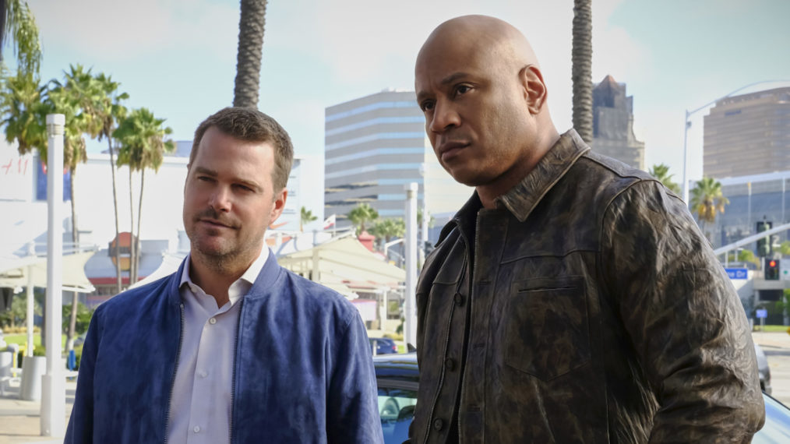

Trae Patton/CBS

### **CBS procedurals, including the *NCIS*es**

CBS Television Studios is partnering with 21CP Solutions, the country’s preeminent law enforcement and public safety advisory group, to work with their police, crime, and legal dramas’ writing teams. The advisors include “former senior law enforcement officials, civil rights scholars, lawyers, academics, and community thought leaders in police reform and public safety.”

“Providing our writing staffs with the best and most knowledgeable technical advisers offers more inclusivity and perspective,” Tiffany Smith-Anoa’i, Executive Vice President, Diversity and Inclusion, ViacomCBS, said. “With deeper and richer narratives, our shows can convey experiences that are more authentic to the communities they depict.”

“The CBS and 21CP Solutions partnership is a first-of-its kind effort that will provide CBS and its writers with technical advice, based on the historical and current truths and realities of policing, as well as contemporary efforts to transform policing and reimagine public safety,” Ronald Davis, Partner, 21CP Solutions, LLC, added.

“This new partnership will help us ensure that our storytelling continues to produce accurate portrayals of law enforcement, and will hopefully allow us to play a small part in the ongoing reform moving forward,” [***NCIS: Los Angeles***](https://www.tvinsider.com/show/ncis-los-angeles/) showrunner and executive producer R. Scott Gemmill said.

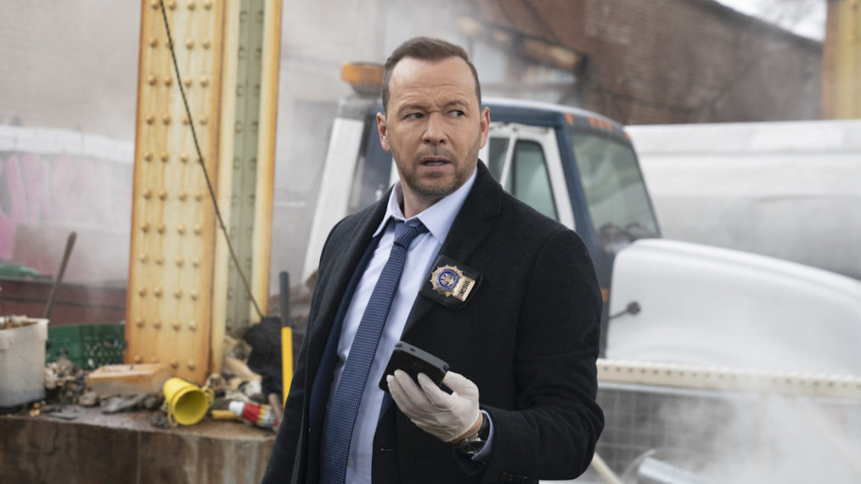

Patrick Harbron/CBS

### ***Blue Bloods***

While the [**Tom Selleck**](https://www.tvinsider.com/people/tom-selleck/)-led drama has featured storylines with characters, including [**Whoopi Goldberg**](https://www.tvinsider.com/people/whoopi-goldberg/) as a City Council Speaker, fighting for social justice in the past, Wahlberg thinks they have to address what’s happening in the world right now in the upcoming 11th season.

“I think we can certainly be more mindful and do a better job of how we do this,” he said. “We are aware that everybody in this country has to take a closer look at themselves right now and of course *Blue Bloods* has to do that as well. It’s a good opportunity for us to really engage in a lot of what’s going on, but also maybe help the discussion and be a part of the discussion.”

The actor also admitted that when they’ve addressed this issue in the past, they’ve “done a great job” and “an OK job.” “We’ll continue to deal with these issues and do it in a way that’s appropriate for the times we’re in,” he continued.

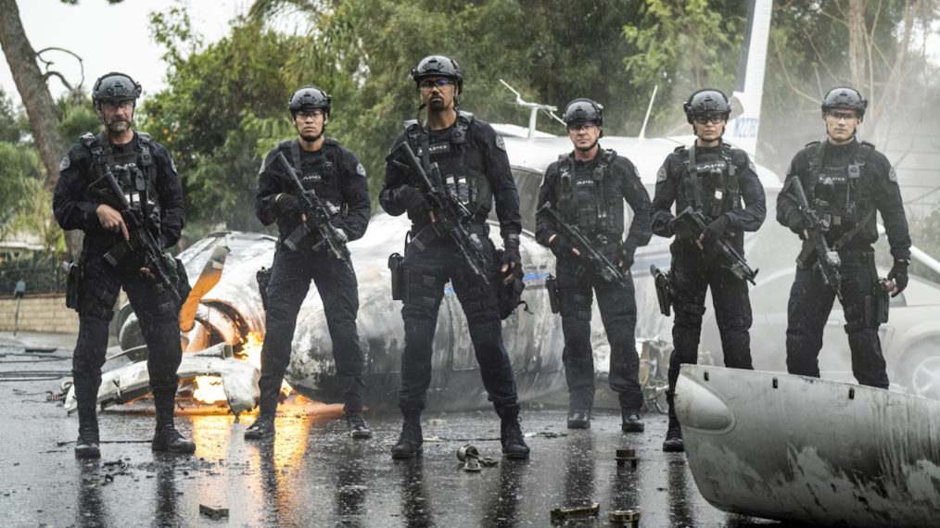

Jordin Althaus/CBS

### ***S.W.A.T.***

At the beginning of June, the writers of the [**Shemar Moore**](https://www.tvinsider.com/people/shemar-moore/)-led procedural, following a S.W.A.T. unit in Los Angeles, addressed the real-world events and promised to continue “to tell stories that have explored themes of race and policing in minority communities.”

“When [***S.W.A.T.***](https://www.tvinsider.com/show/s-w-a-t/) began three years ago on CBS, as writers we examined the intersection of black community and law enforcement through the eyes of Daniel ‘Hondo’ Harrelson, an African-American cop who has one foot firmly planted in each world. … We also asked questions about what is required to build trust and bridge these two worlds,” the [**statement**](https://twitter.com/SWATWritersRoom/status/1267626544047853568) posted to Twitter read.

“We are watching recent events in horror and sadness along with everyone else and will continue to mine the truth about these issues in the writing of our upcoming season as we all work towards a fairer, better system,” the writers said.

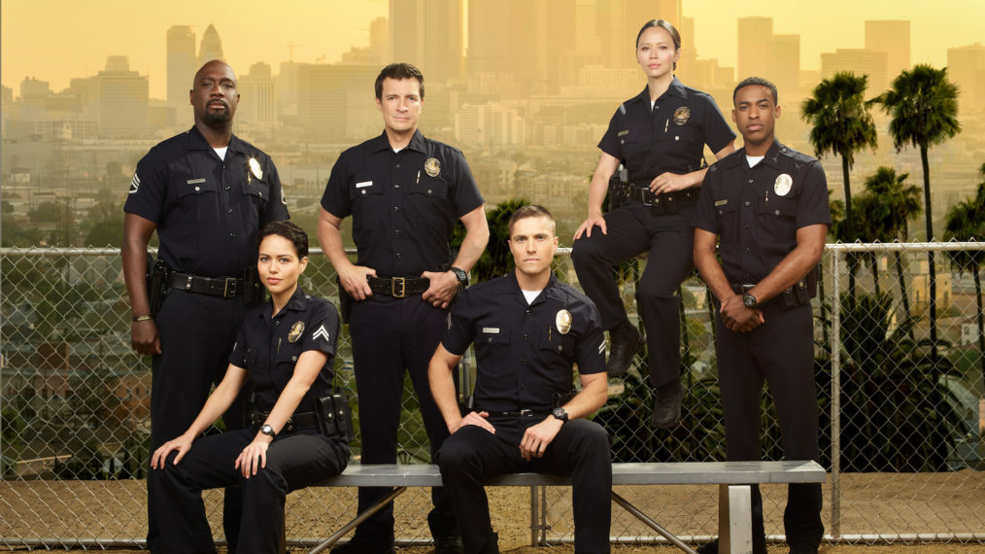

ABC/Andrew Eccles

### ***The Rookie***

The writers of the ABC procedural centered around [**Nathan Fillion’s**](https://www.tvinsider.com/people/nathan-fillion/) John Nolan, the LAPD’s oldest rookie, were already discussing addressing issues surrounding [**policing in Season 3**](https://www.tvinsider.com/938672/the-rookie-police-brutality-season-3-abc/).

“[Showrunner] [**Alexi Hawley**](https://www.tvinsider.com/people/alexi-hawley/) is a really thoughtful ally and partner and has been in the writers’ room for some time, already planning to address the current conversation going on around police work,” ABC Entertainment President Karey Burke shared. “It’s a diverse writers room and I’m hearing that the conversations going on in that room are inspired and give me hope that that show will address and not ignore the conversations around policing.”

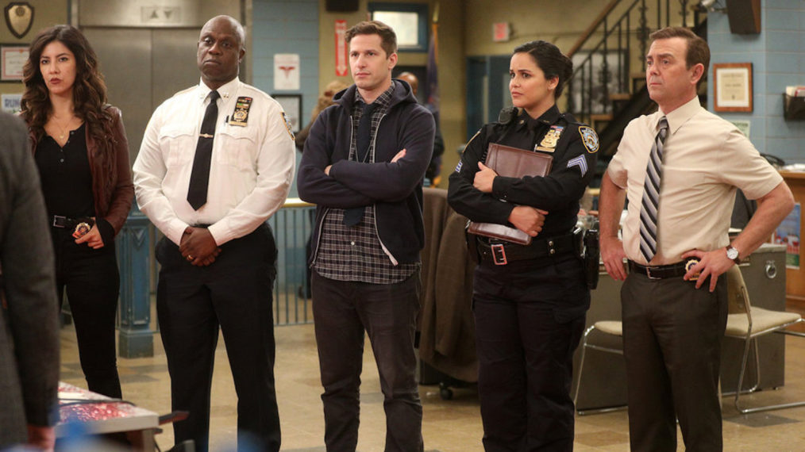

Jordin Althaus/NBC

### ***Brooklyn Nine-Nine***

The NBC series about police working out of a precinct in Brooklyn may be a comedy, but there are also changes in store for its eighth season. [**Terry Crews**](https://www.tvinsider.com/people/terry-crews/) (who plays Lieutenant Terry Jeffords) revealed they threw out the [**four scripts they’d had completed**](https://www.tvinsider.com/939463/brooklyn-nine-nine-season-8-episodes-police-protests/) for the new season, while [**Andy Samberg**](https://www.tvinsider.com/people/andy-samberg/) (Detective Jake Peralta) shared the writers are “[**rethinking**](https://www.tvinsider.com/940789/brooklyn-nine-nine-season-8-police-brutality-storylines/) how we’re going to move forward.”

Conversations are taking place with the cast and writers, including “how you make a comedy show about police right now, and if we can find a way of doing that that we all feel morally okay about,” Samberg said.



Virginia Sherwood/NBC

### ***Law & Order: SVU***

Showrunner Warren Leight told [***The Hollywood Reporter***](https://www.hollywoodreporter.com/live-feed/tvs-top-5-a-conversation-police-hollywood-law-order-svu-showrunner-1297222) in June soon after they had reopened the writers room that they were discussing how to reflect real-world events onscreen. “We altered a teaser to have somebody who’s assumed to be guilty because he’s Black and he’s in the wrong place, and we added the extra beat that they can arrest him on the spot because he was arrested during demonstrations and he didn’t show up for a desk appearance, so there’s a warrant out on him,” he shared.

“We try to be of the moment,” he continued, pointing out their focus is through the cops and victims’ eyes. While two of their six main characters are Black ([**Ice-T**](https://www.tvinsider.com/people/ice-t/) and Demore Barnes) and they do have a diverse cast, “we’ll be looking to bring in more that way to tell that side of the story as well,” he added.

George Floyd’s death and the protests “has to come up, and it will,” Leight added. “It’ll come up when we arrest somebody.” They have shown in the past that when someone’s arrested on the street, people record it on their phones. The series will also show “the obstacles it presents to Carisi ([**Peter Scanavino**](https://www.tvinsider.com/people/peter-scanavino/)), our district attorney, because he knows the cop on the stand isn’t going to be believed at the moment.”